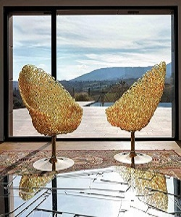

Modern Oval Chairs

$26.14

Availability: In stock

### Description

Modern Golden Oval chairs with single steel legs to ensure stability and support. The chair is made of polycarbonate (plastic) threads which, while being still hot, are connected in the openwork chaotic lace “weaved” and turned manually into a chair. Large and tall. It is available in four colors: gold **(**the gold color contains a 24-carat gold bar**)**, red, aqua and amber. The shell rests supported by a conical pedestal of steel, brushed and finished in different colors.